**Steps to create Gatling Project with scala**

• Create folder where you want to have project

• Go to command prompt and above location

• Run command to create new project

mvn archetype:generate

• Define property value for:

• groupId

• example like-com.<companyname>.gatling

• artifactId

• Indicate project name-example like – my-gatling-project

• version: “1.0-SNAPSHOT”

• package: “package”

• Confirm your selections and create project

Attached Screen shot

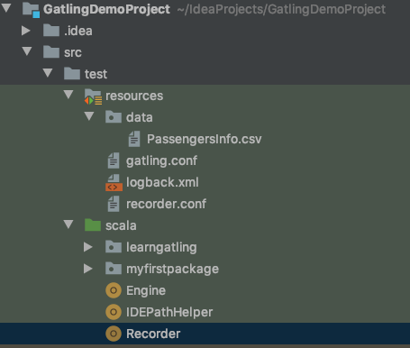

**Test to run-**

Right click on Engine and run it.

it will ask the main file

select that file.

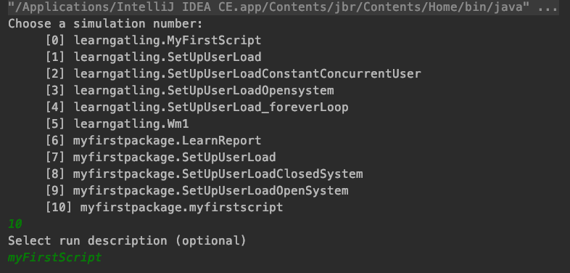

Here it means the test case which you want to run and provide optional Description

wait for some time according to your config it will take time.

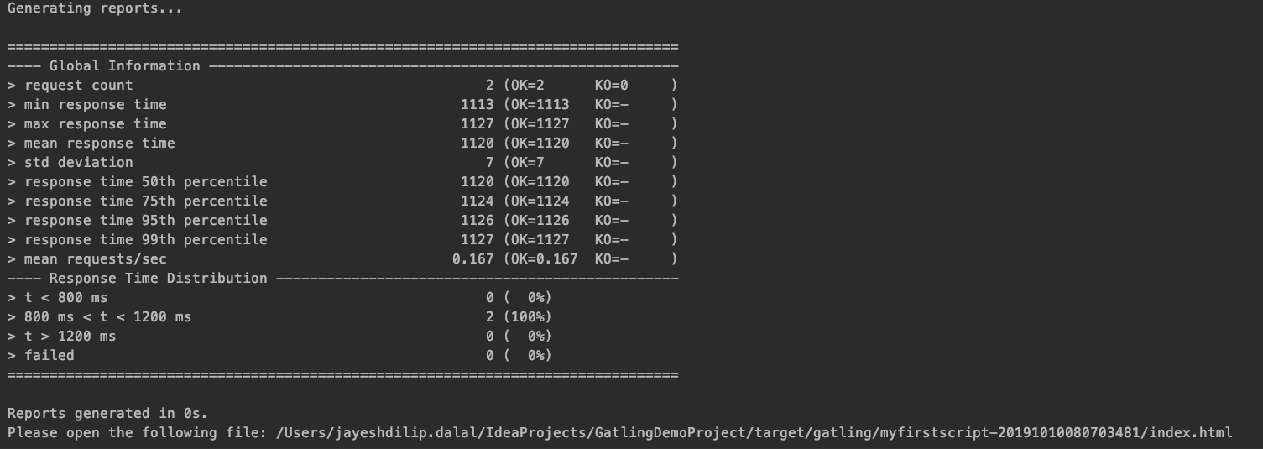

It will generate the reports and logs under target folder.

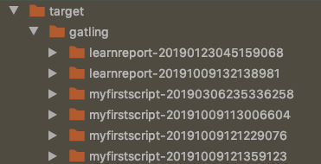

When you open a Reports it will look like

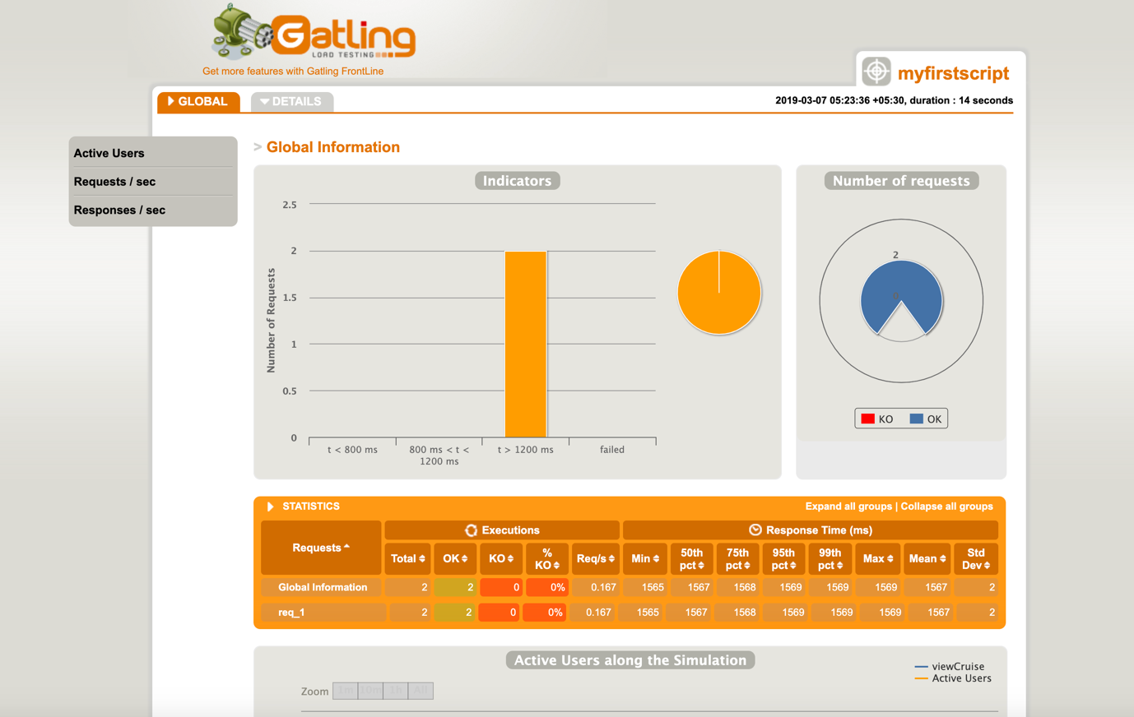

It will also has many other feature.

For more info please visit [GatlingGitHub](https://github.com/gatling/gatling)